Class Notes / PowerPoint Presentation / Textbook Notes
American Government

Name:
Class:
Date:

Chapter 4: Federalism / Section 1: Powers Shared & Divided
Objectives | - Define federalism and explain why the Framers chose this system.  - Identify powers delegated to and denied to the National Government, and powers reserved for and denied to the States.  - Explain the difference between exclusive and concurrent powers.  - Examine the Constitution as “the supreme Law of the Land.”
- Essential Question | Is the federal system the best way to govern the United States?
- Focus Question | In what ways does the Constitution support a Federal government system?
Key Terms
federalism | a system of government in which a written constitution divides power between a central government and several regional governments
division of powers | assigning some powers to the federal government and others to the States
delegated powers | powers granted by the Constitution
expressed powers | powers specified clearly in the Constitution
implied powers | powers not specifically mentioned, but suggested by the expressed powers
inherent powers | powers that belong to all independent national governments
reserved powers | powers not given to the national government or denied to the States
exclusive powers | powers that can only be used by the national government
concurrent powers | powers shared by the national and State governments
Supremacy Clause | the provision declaring the Constitution to be the supreme law of the  land
Introduction | How is power divided between the Federal Government and the States?
Federalism
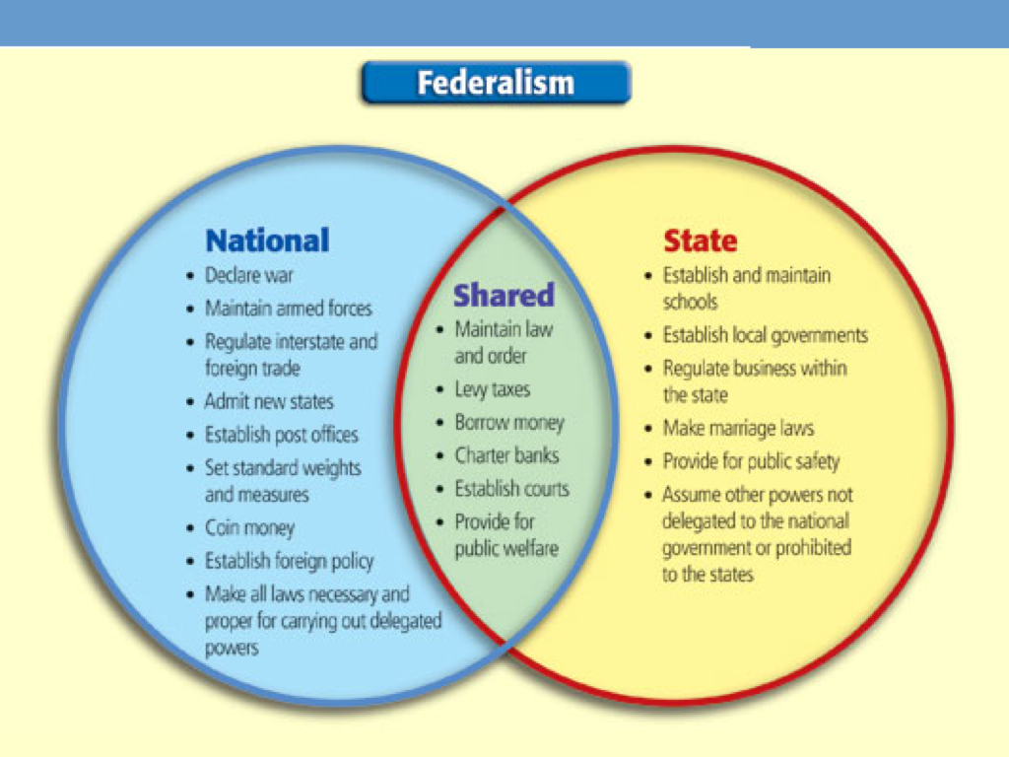
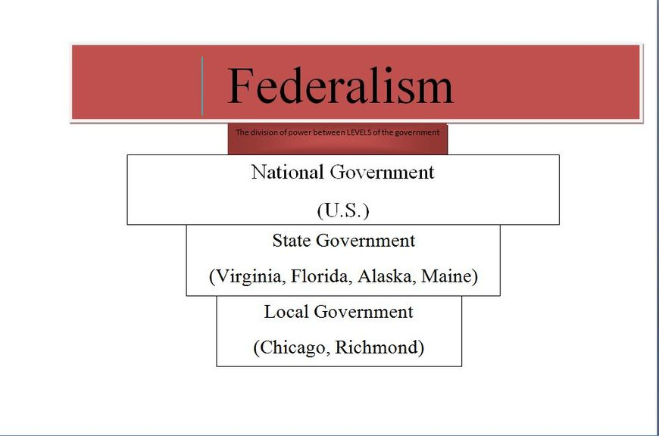
Inherent Powers

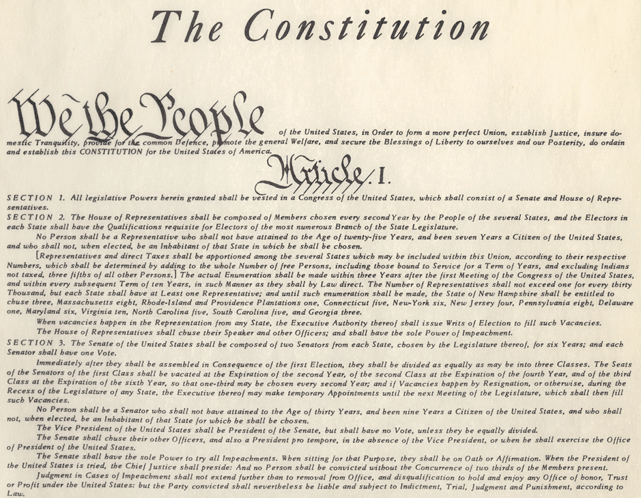
Denied Powers

State Reserved Powers

State Reserved Powers
(CONT’D)

Powers Denied
to the States

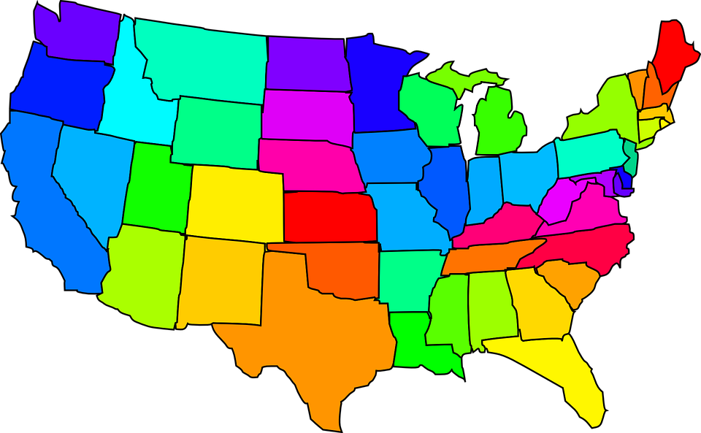
Concurrent Powers

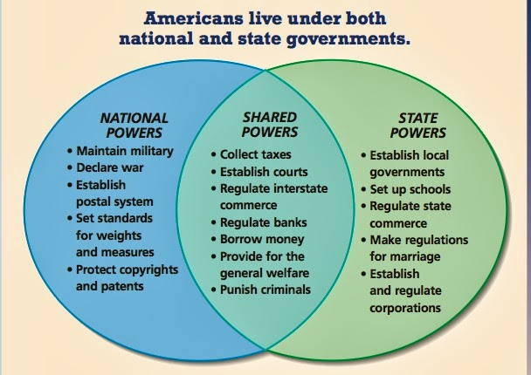

Sharing Responsibility

Supreme Law

ESSENTIAL QUESTION  REVIEW | Is the federal system the best way to govern the United States? Why or why not?

