Class Notes / PowerPoint Presentation / Textbook Notes
American Government

Name:
Class:
Date:

Chapter 3: The Constitution / Section 3: Interpreting the Constitution
ESSENTIAL  QUESTION | - How has the Constitution endured through changing times?
FOCUS QUESTION | - How has Congress impacted & changed our Constitution?  - What affect have the 3 branches of government & political parties had on the interpretation of the Constitution?
Objectives | - Identify how basic legislation has added to our understanding of the Constitution over time.  - Describe the ways in which the executive and judicial branches have interpreted the Constitution.  - Analyze the role of party practices and custom in interpreting the Constitution.
Key Terms
executive order
executive agreement | a pact made by the President directly with the head of a foreign state
treaty | a formal agreement between two or more independent states
electoral college | the body of electors that makes the formal selection of the President
Cabinet | a body made up of the heads of the 15 executive departments that advises the President
senatorial courtesy | the Senate custom of refusing to approve any presidential appointee unless that person has the support of all Senators from the appointee’s home state who belong to the same party as the President
Introduction  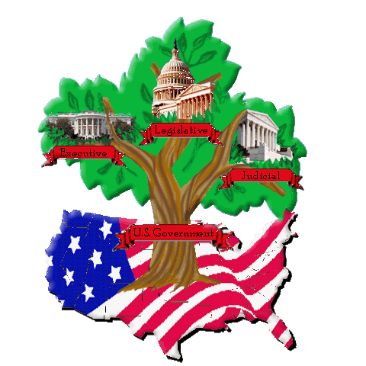 | How have the day-to-day workings of the government affected how we interpret the Constitution?
The Role of Congress

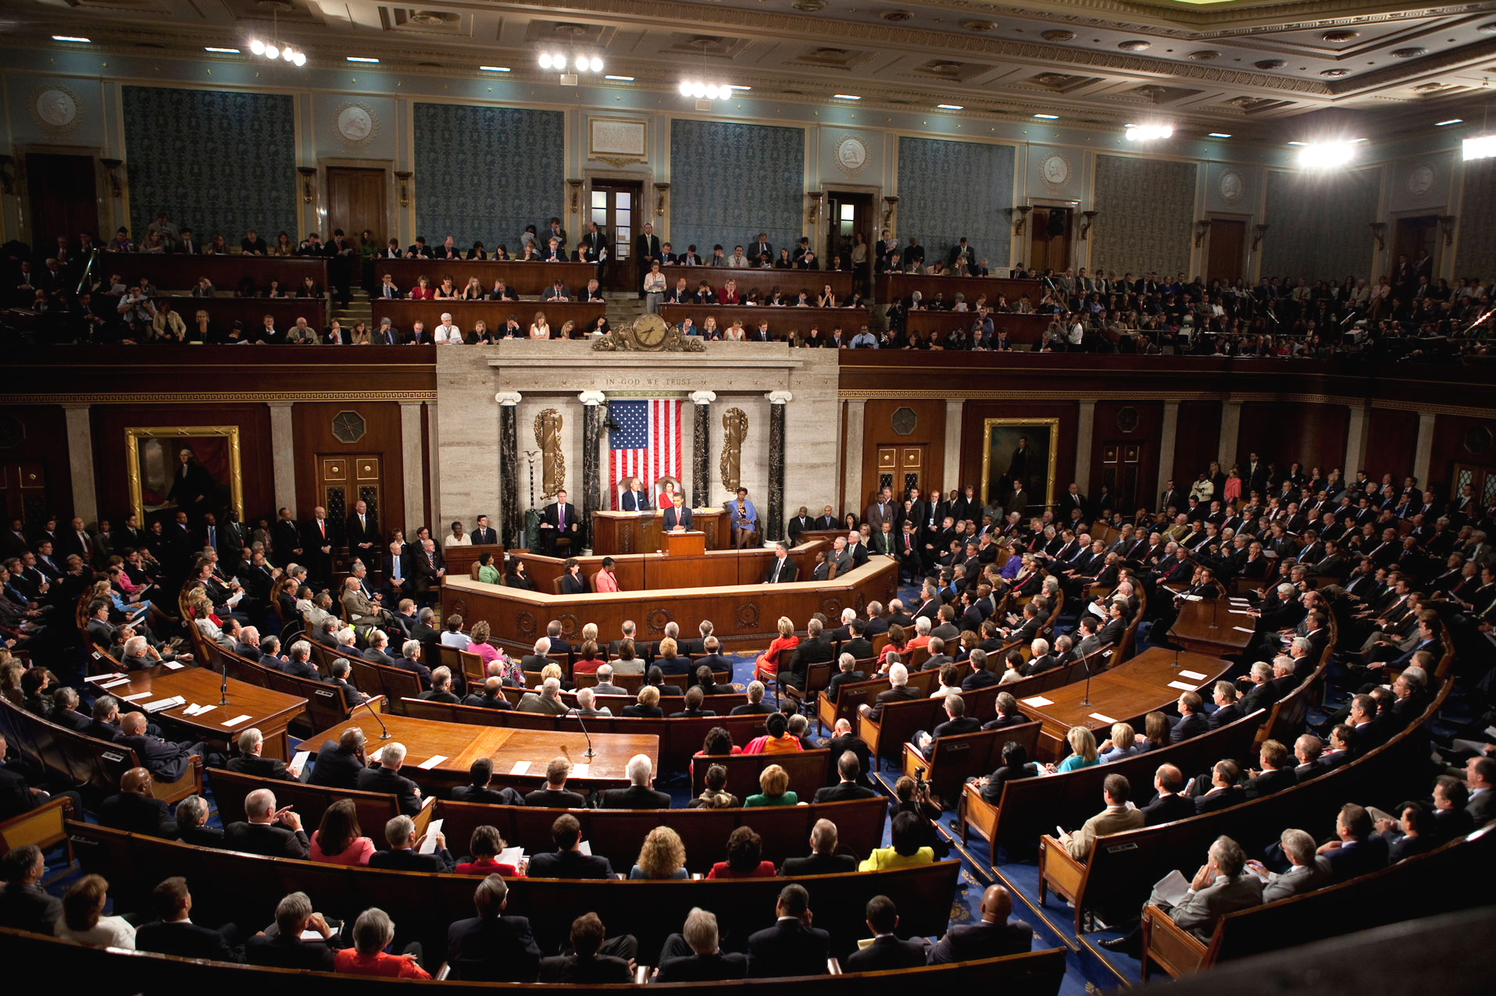
Powers of Congress

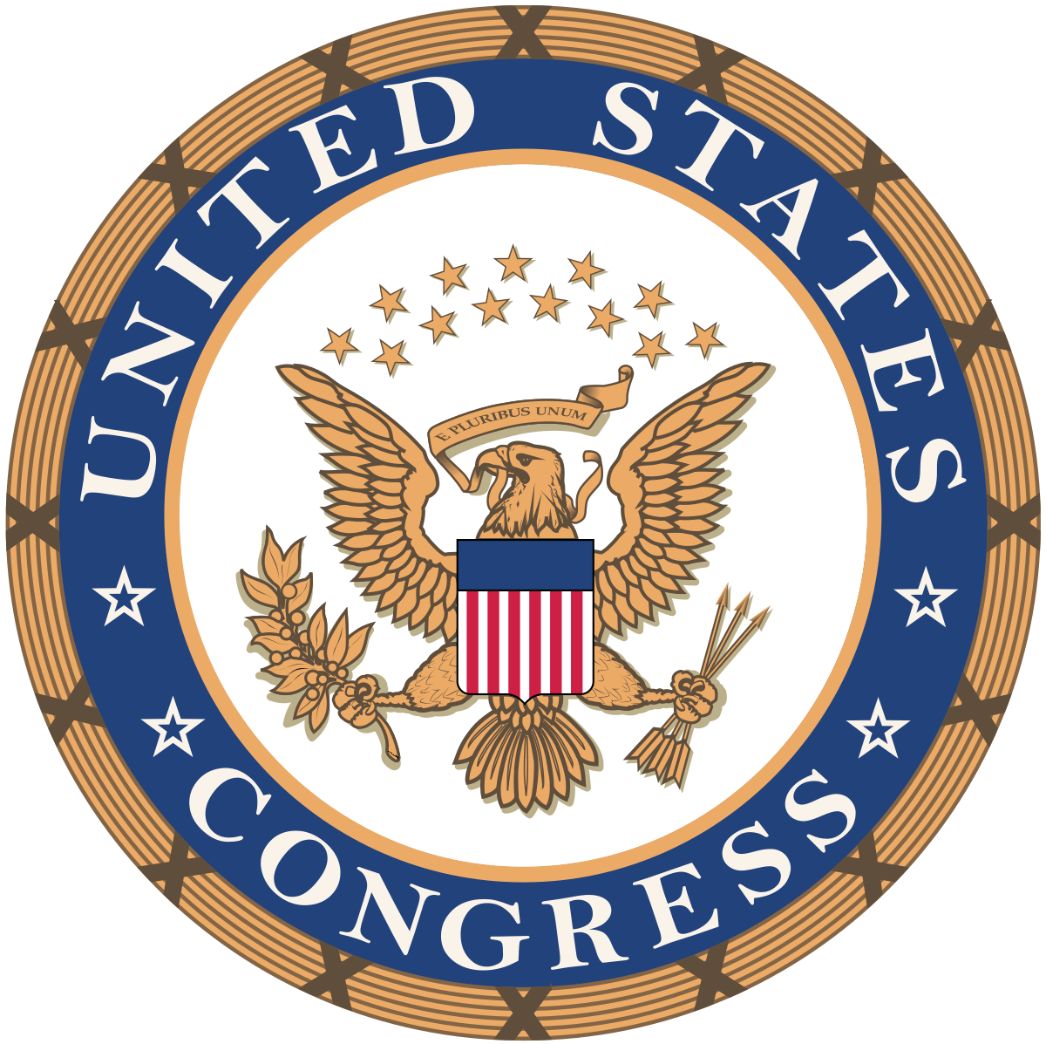
Expanding Executive Power

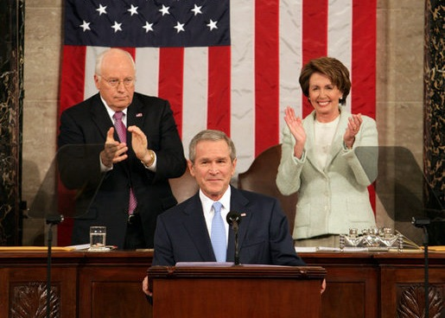
Presidential Power

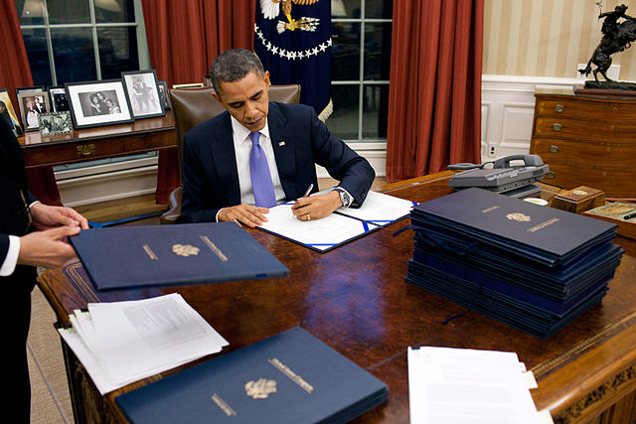

The State of the Union

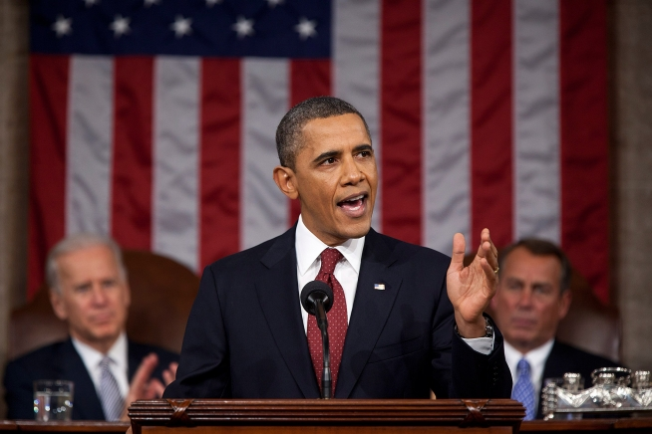
The Courts

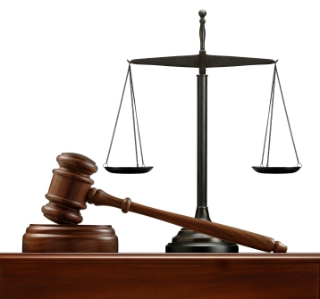
Political Parties

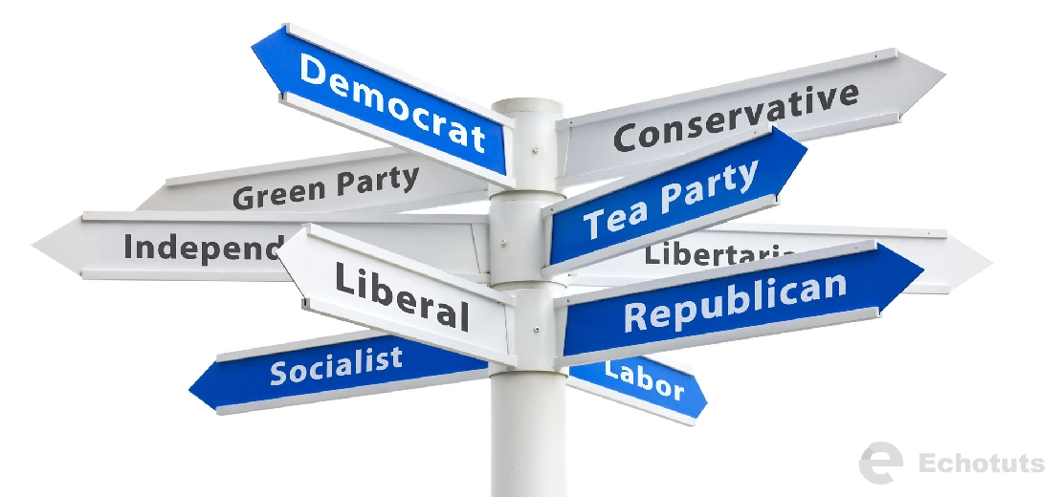

Political Parties
(CONT’D)

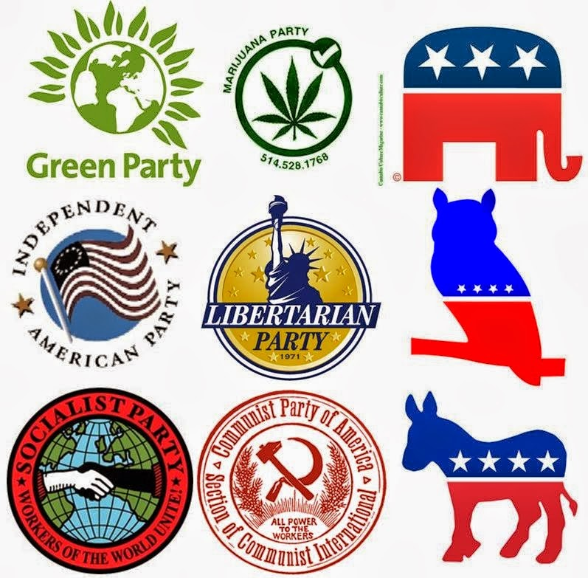

CHECKPOINT! | How have political parties changed the way we interpret the Constitution?
Customs

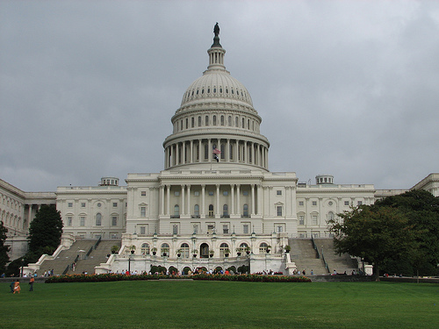
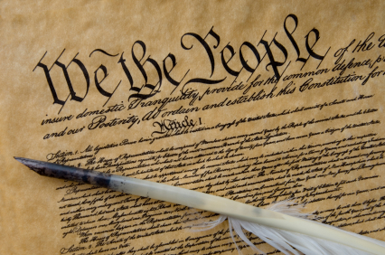
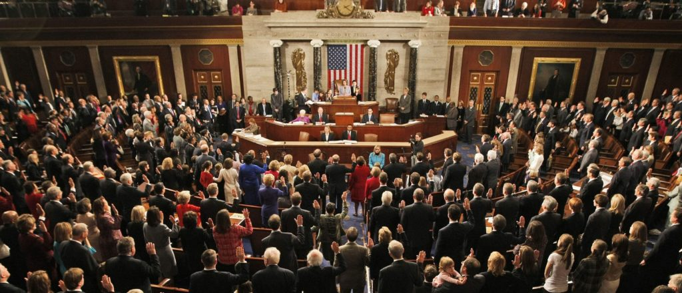

CHECKPOINT! | Which customs did the 22nd and 25th Amendments establish as laws?
CHECKPOINT!  The 3 Branches of Government & the U.S. Constitution | A). How has Legislative Branch (Congress) impacted and changed the Constitution? Give an example & explain.  B). How has the Executive Branch (the President) impacted & changed the Constitution? Give an example & explain.  C). How has the Judicial Branch (the courts) impacted & changed the Constitution? Give an example & explain.

