Class Notes / PowerPoint Presentation / Textbook Notes
American Government

Name:
Class:
Date:

Chapter 3: The Constitution / Section 1: Main Principles of the Constitution
ESSENTIAL  QUESTION | How has the Constitution lasted through changing times?
FOCUS QUESTION | What are the 6 main principles upon which the U.S. Constitution is built? What are the relationships between each of the 6 principles & how do they work together?
Objectives | - Understand the basic outline of the Constitution.  - Understand the six basic principles of the Constitution: popular sovereignty, limited government, separation of powers, checks and balances, judicial review, and federalism.
Key Terms

popular sovereignty | the political principle that people are the source of all governmental power and that government requires the consent of the governed
limited government | the idea that government may only do those things that the people have given it the power to do
Constitutionalism | the idea that government must be conducted according to constitutional principles
rule of law | the principle that government and its officers must always  obey the laws of the land
separation of powers | the principle that each of the basic powers of government—executive, legislative, and judicial—should be wielded by an independent branch of government
checks and balances | the system under which each branch of government can check, or limit, the actions of the other branches
veto | to reject an act of Congress
judicial review | the power of a court to determine whether a government action is constitutional or not
Introduction | - What are the six main principles on which the Constitution is based?
Outline of the Constitution

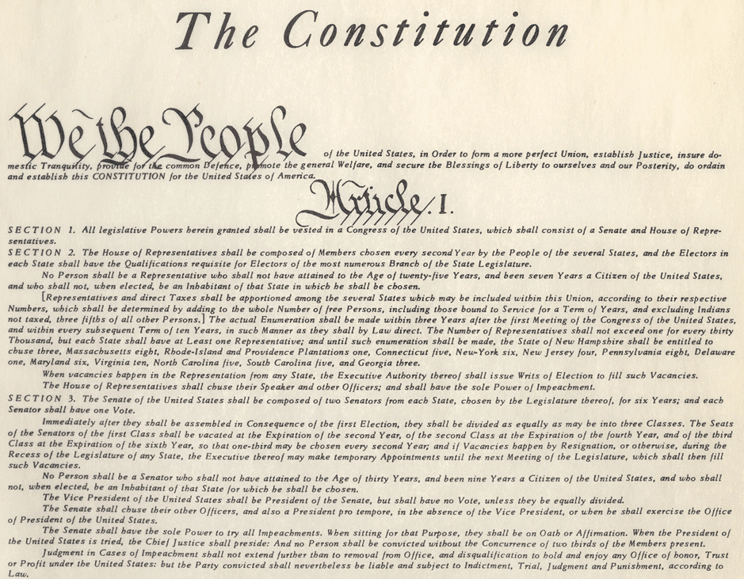
The 6 Constitutional Principles

- Popular Sovereignty | Example:
- Limited Government  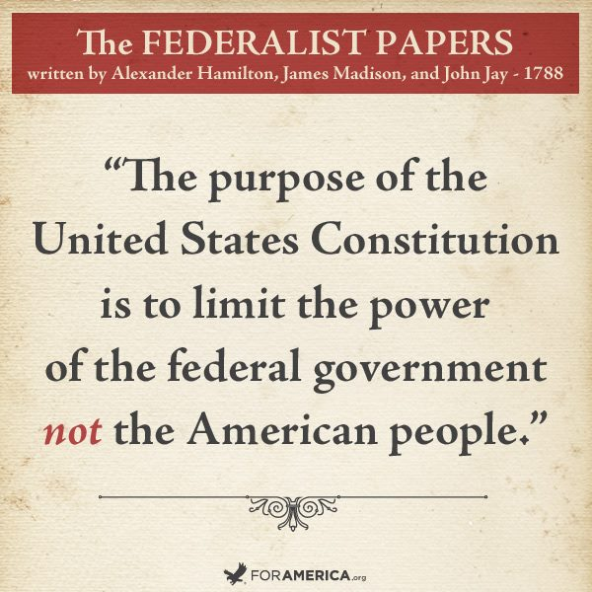 | Example:
- Separation of Powers  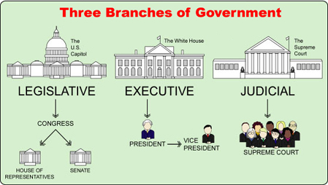 | Example:
CHECKPOINT! | How does the separation of powers keep government from becoming too powerful?
- Checks and Balances  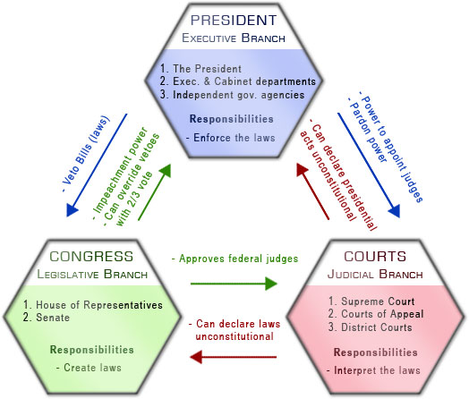 | Example:
- Judicial Review  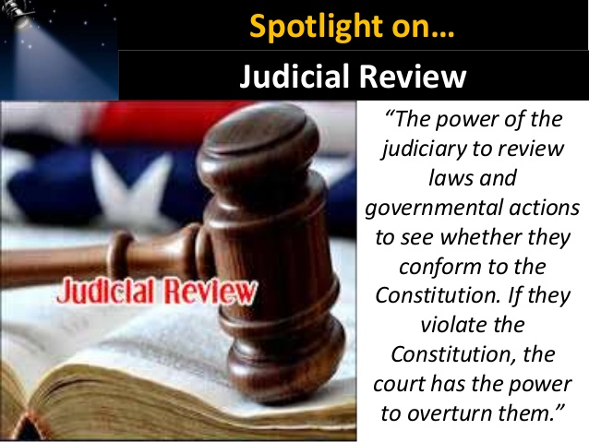 | Example:
- Federalism  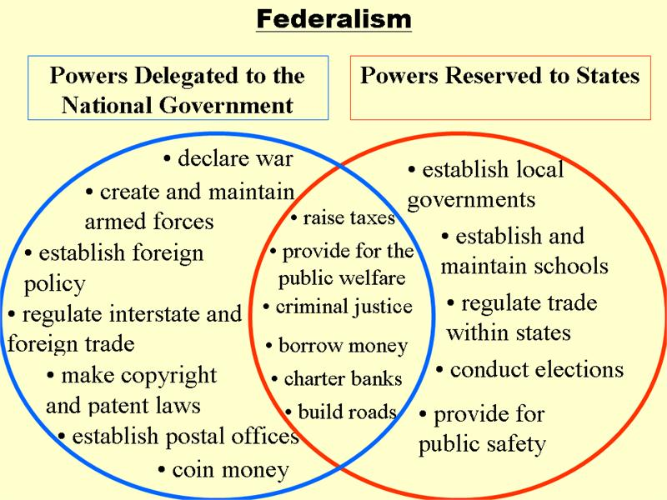 | Federalism is a compromise between an all-powerful central government and an independent state government.  Example:
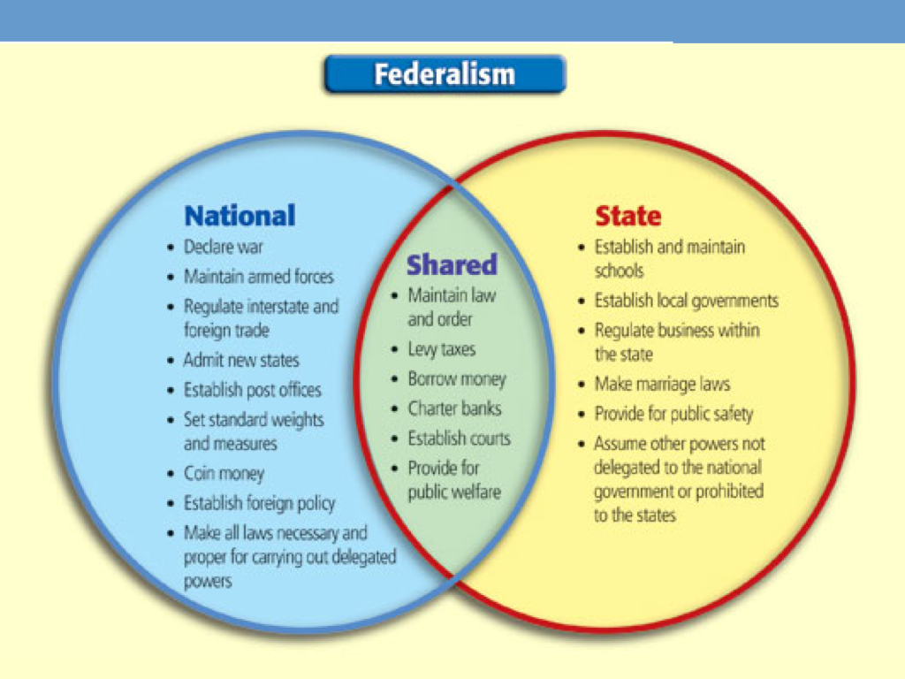 | Why might the Constitution give the power to regulate trade among the States to the Federal Government?
CHECKPOINT!  *Relationships: The 6 Constitutional Principles | DIRECTIONS: Describe the relationship between the 6 Main Principles of the U.S. Constitution. How do the principles work together in support of one another? Explain by completing the missing information below. Use each principle & provide an explanation of the relationship between the two principles you’ve selected for parts A, B & C below.  A).  _____________________ supports ________________________  because_______________________________________________________________________________________________________________________________________________________  B).  _____________________ supports ________________________  because___________________________________________________________________________________________________________________________________________________________  C).  _____________________ supports ________________________  because______________________________________________________________________________________________________

