Class Notes / PowerPoint Presentation / Textbook Notes
American Government

Name:
Period:
Date:

Chapter 2: Origins of Government / Section 3: The Critical Period
Objectives | - Describe the structure of the government set up under the Articles of Confederation.  - Explain why the weaknesses of the Articles led to a critical period for the country in the 1780s.  - Describe how a growing need for a stronger national government led to plans for a Constitutional Convention.
Key Terms
Articles of Confederation | the agreement, effective in 1781, that established the first central government of the United States as a confederation government
ratification | formal approval of a proposal, agreement, law, treaty or constitution
FOCUS QUESTION | - What weaknesses in the Articles of Confederation made a lasting government impossible?
Articles of Confederation

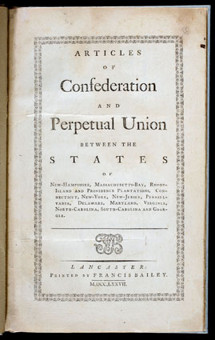
Government Structure

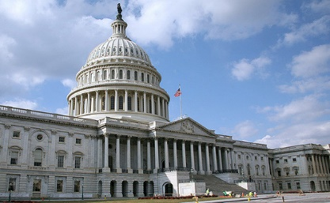

Powers of Congress
& State Obligations

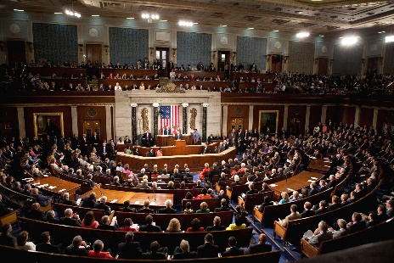

CHECKPOINT! | - What powers did Congress hold under the Articles of Confederation?
Weaknesses of the Articles of Confederation

The Critical Period,
The 1780’s
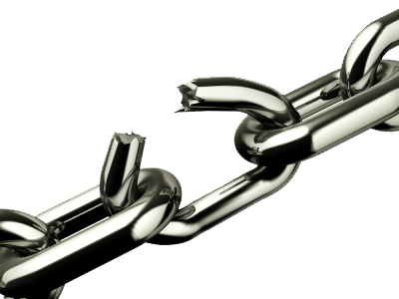

Shays’ Rebellion

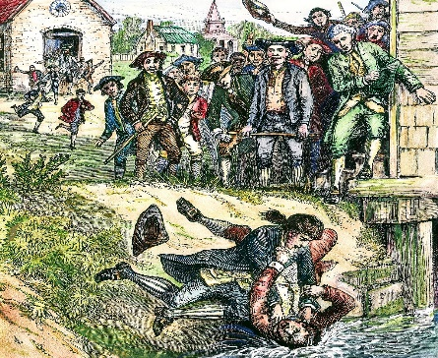

CHECKPOINT! | - How did events in the 1780s reveal the economic &  political weaknesses of the Articles of Confederation?
The Need for Stronger Government

