Class Notes / PowerPoint Presentation / Textbook Notes
American Government

Name:
Period:
Date:

Chapter 2: Origins of American Government / Section 2: The Coming of Independence
Objectives | - Explain how Britain’s colonial policies contributed to the growth of self-government in the colonies.  - Identify the major steps that led to growing feelings of colonial unity.  - Compare the First and the Second Continental Congresses.  - Analyze the ideas in the Declaration of Independence.  - Summarize the common features of the first State constitutions.
Key Terms
confederation | a joining of several different groups for a common purpose
Albany Plan of Union | Benjamin Franklin’s proposal that the 13 colonies form a congress to raise armed forces, regulate trade, and deal jointly with Native Americans
delegate | a representative
popular sovereignty: | the principle that government exists only with the consent of the governed
Introduction | - What events and ideas led to American independence?
Britain’s Colonial Policies

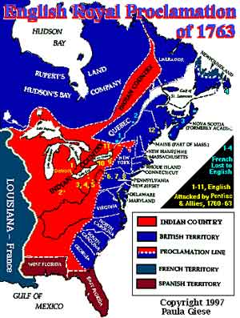

CHECKPOINT! | - How did Britain’s dealings with the colonies change? When did they change & why?
Growing Colonial Unity

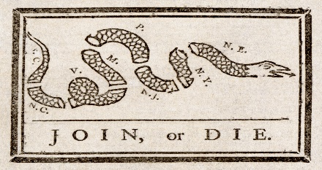
Early Attempts to Unite

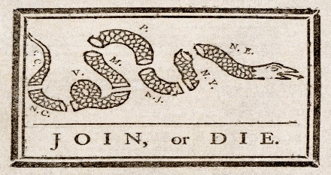

The Albany Plan

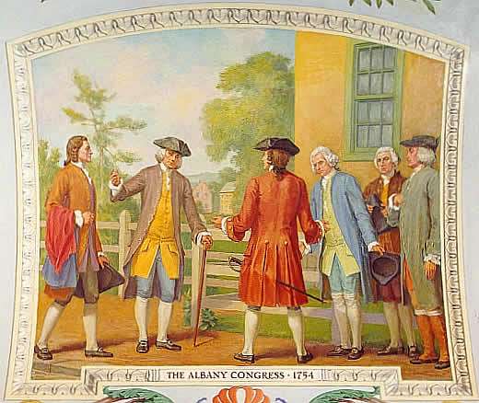

Stamp Act Congress

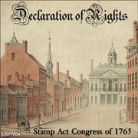
First Continental Congress

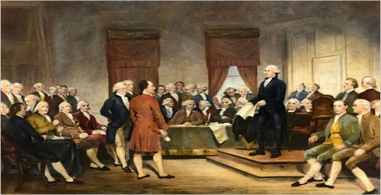

CHECKPOINT! | - What did the First Continental Congress accomplish?
Second Continental Congress  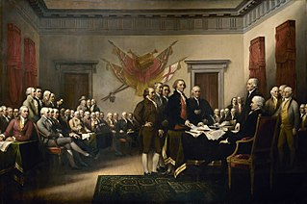 | The Delegates  Our First National Government
Declaration of Independence

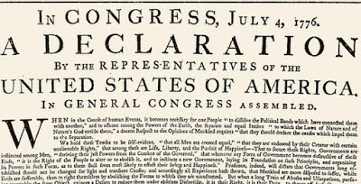

CHECKPOINT! | - What did the Second Continental Congress accomplish?  - What was the purpose of the Declaration of Independence?
The Road to Independence
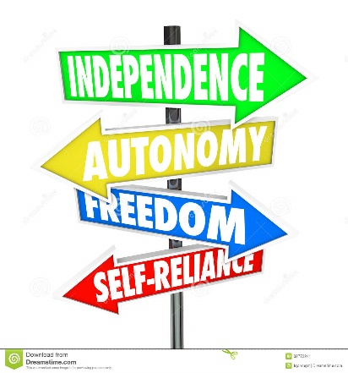
CHECKPOINT! | - How did early events contribute to the signing of the Declaration of Independence?
State Constitutions

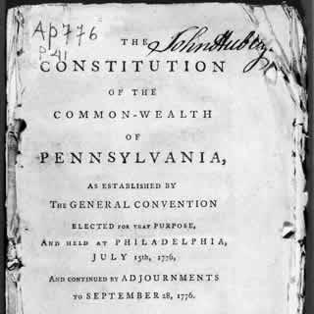

CHECKPOINT! | - How did the state constitutions separate governmental power?  - What important rights & liberties did they include?
Review | - How does the Constitution that was written in the late 1700’s still meet the expectations and standards of Americans in the year 2018?

