Class Notes / PowerPoint Presentation / Textbook Notes
American Government

Name:
Period:
Date:

Chapter 2: Origins of American Government / Section 1: Our Political Beginnings
ESSENTIAL QUESTION | How does the U.S. Constitution reflect the times in which it was written?
Objectives | - Identify the three concepts of government that influenced the American colonies.  - Explain the influence of three landmark English documents.  - Describe the three types of colonies that the English established in the American colonies.
Key Terms
limited government | the idea that government is restricted in what it may do and that every individual has certain rights that government cannot remove
representative government | the idea that government should both serve and be guided by the will of the people
Magna Carta | the Great Charter signed in 1215 that limited the powers of the English king and guaranteed certain fundamental rights
due process | protection against the unjust taking of life, liberty, or property
Petition of Right | a document signed in 1628 that required the English king to obey the law of the land and increased the influence of Parliament
English Bill of Rights | a document signed in 1689 that required free elections and guaranteed many basic rights, such as due process and trial by jury, to all English citizens
charter | a written grant of authority from the king
bicameral | having two houses, as in a two-house legislature
proprietary | the name given to colonies organized and governed according to the will of a proprietor, a person granted land and authority by the king
unicameral | having only one house, as in a one house legislature
GUIDING QUESTION | What ideas and traditions influenced government in the English Colonies?
Basic Concepts of Government  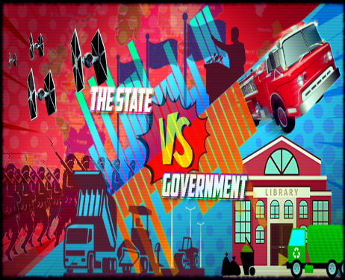 | Ordered Government  Limited Government  Representative Government
CHECKPOINT | - What is representative government?
Landmark English Documents | 3 important documents from England that greatly influenced the evolution of democracy, natural rights & Enlightenment thinking in America.
The Magna Carta

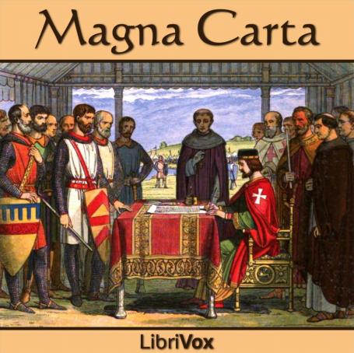
The Petition of Right

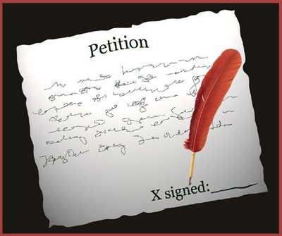
English Bill of Rights

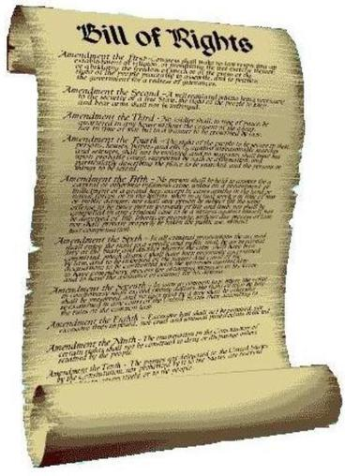

CHECKPOINTS!  CHECKPOINTS! | - How did the Magna Carta limit the power of the King of England?  - Why was the English Petition of Right so significant to the evolution of democracy?  - What were the limitations set by the English Bill of Rights?  MAKING CONNECTIONS – PAST to PRESENT  - Review your notes on each of the 3 landmark English documents. Then, explain how each of them influence our democracy & form of government in the USA today:  - Magna Carta (1215)  - Petition of Right (1628)  - English Bill of Rights (1689)
The Thirteen Colonies

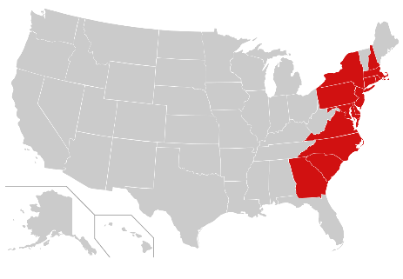
Royal Colonies
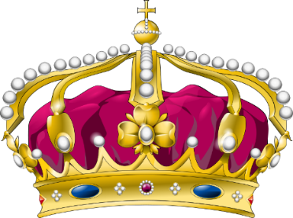
Proprietary Colonies

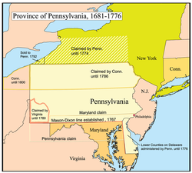
Charter Colonies

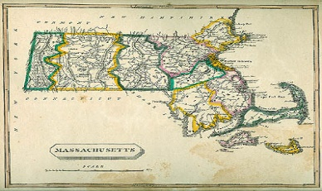
CHECKPOINT! | - What is the difference between a proprietary colony & a charter colony?
MAKING CONNECTIONS:  Past to Present | Use the information from your notes for Ch.2.1 & respond to the following question:  - How does the U.S. Constitution reflect the times in which it was written?

