Class Notes / PowerPoint Presentation / Textbook Notes

American Government

Name:
Hour:
Date:

Chapter 1: Principles of Government / Section 3: Basic Concepts of Democracy
FOCUS QUESTION | WHAT ARE THE CHARACTERISITICS OF A DEMOCRACY?
Objectives | - Understand the foundations of democracy.  - Analyze the connections between democracy and the free enterprise system.
Key Terms
majority rule | the principle that the will of the majority controls the actions of government
compromise | the process of blending and adjusting competing views and interests
citizen | one who holds certain rights and responsibilities within a state
free enterprise system | an economic system characterized by the private ownership of capital goods, private investment, and a competitive marketplace that determines success or failure
Introduction | What are the basic concepts of democracy?
Worth of the Individual

Equality of All Persons
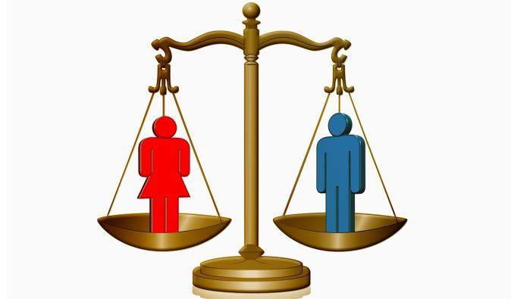
CHECKPOINT! | To what are citizens entitled under the democratic concept of equality?
Majority Rule,  Minority Rights  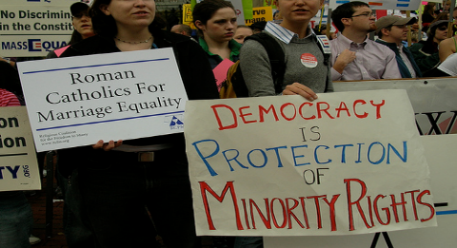 | 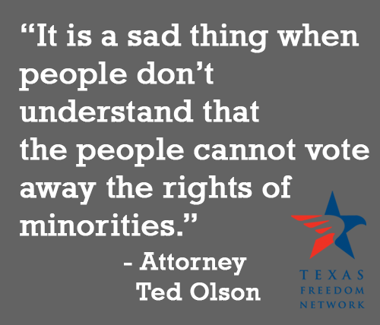
Necessity of Compromise

Individual Freedom

CHECKPOINT! | - GRAPHIC ORGANIZER – 5 CONCEPTS OF DEMOCRACY  - Explain the relationship between each of the 5 Basic Concepts of Democracy using the graphic organizer.  - Make connections between each of the concepts by drawing lines from one concept to another & explain how they are related (e.g. cause & effect relationships, how one supports the other, etc.)
Citizenship

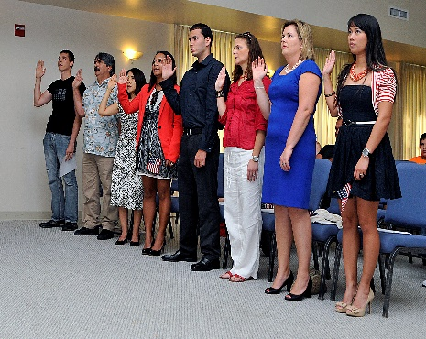
Citizenship  - CONTRAST –  Duties vs. Responsibilities | Duties Responsibilities  Duties of citizenship are… - Examples: Responsibilities of citizenship are… - Examples:
Citizenship Overview | What does being (or becoming) a U.S. Citizen mean to you?
Democracy & the Free Enterprise Economic System
Government and Free Enterprise
CHECKPOINT! | - Explain the relationship between democracy & the free enterprise economic system?  - How do they support each other?  - How might they work against each other?

