Class Notes / PowerPoint Presentation / Textbook Notes

American Government

Name:
Hour:
Date:

Chapter 1: Principles of Government / Section 2: Forms of Government
Focus Question | What are some different types of government in the world today?
Objectives | - Classify governments according to three sets of characteristics.  - Define systems of government based on who can participate.  - Identify different ways that power can be distributed, geographically, within a state.  - Describe a government by the distribution of power between the executive and legislative branch.
Key Terms
autocracy | government in which a single person holds all political power
oligarchy | government in which a small, usually self-appointed group has the sole power to rule
unitary government | a government in which all power belongs to one central agency
federal government | a government in which power is divided between one central and several local governments
division of powers | the split of power between central and local governments
confederation | an alliance of independent states
presidential government | a government with separate executive and legislative branches
parliamentary government | a government in which the executive branch is part of the legislative branch and subject to its control
Introduction | - What are some forms of government in the world today?
Direct Democracy
Indirect Democracy
CHECKPOINT! | What are the main differences between a direct democracy & indirect democracy?  What are two PROs & CONs for both types of democracies?  *DIRECT DEMOCRACY*  PROS CONS  *INDIRECT DEMOCRACY*  PROS CONS
Example Democracies

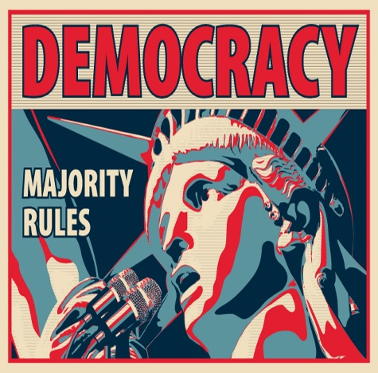
Dictatorships
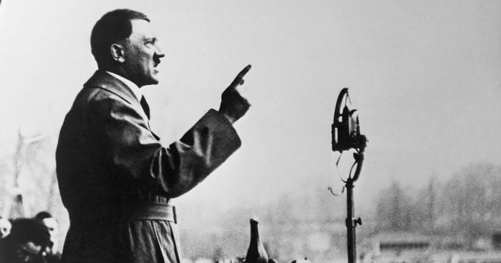
Example Dictatorships
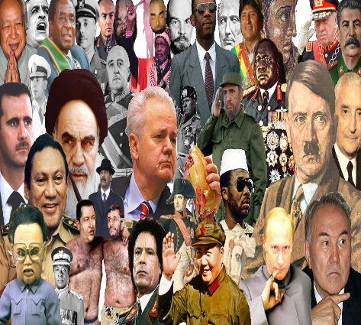
CHECKPOINT! | What is the difference between an oligarchy and an autocracy? Give an example for each form of government.
Unitary Government
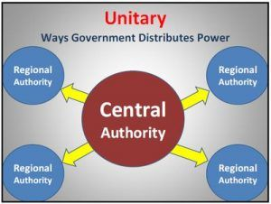
Federal Government
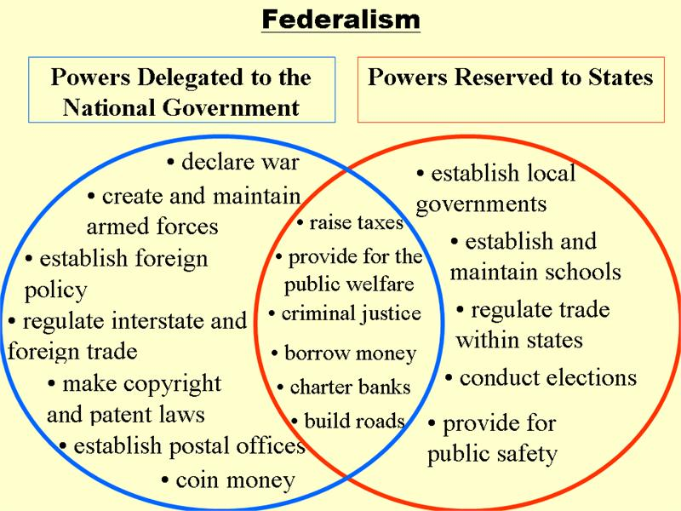
Confederate Government
CHECKPOINT! | 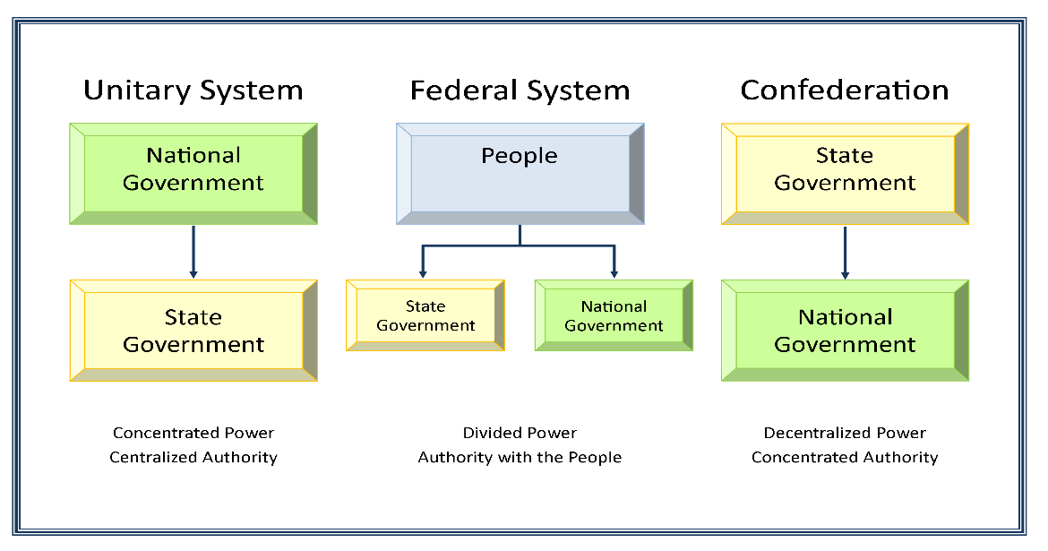
Presidential Government
Parliamentary Government

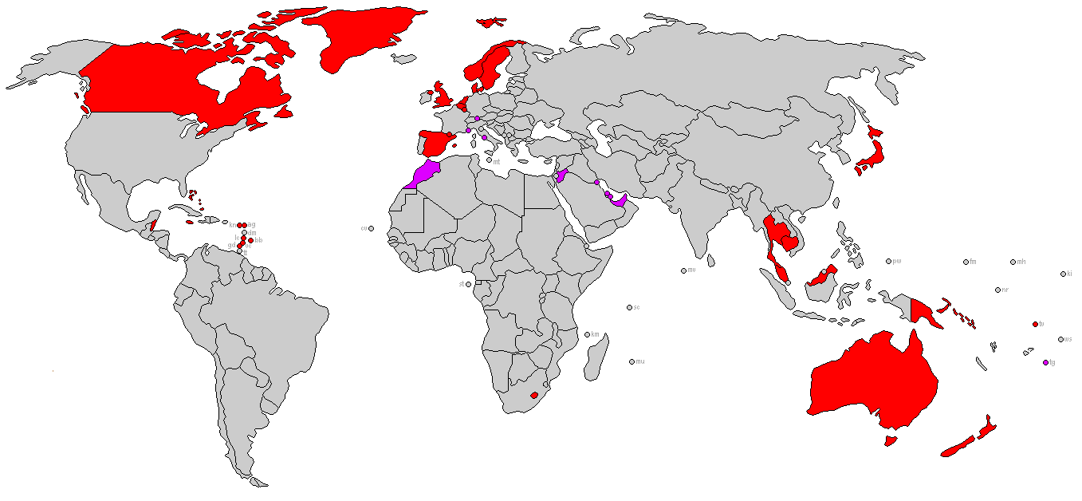

CHECKPOINT! | What are the key differences between a Presidential Government & Parliamentary Government? Give an example (nation state) for each.
Complete the chart below to compare (similarity) & contrast (difference) the following forms of government:
 | Unitary Government | Federal Government | Confederation Government
Compare
Contrast

