Class Notes / PowerPoint Presentation / Textbook Notes

American Government

Name:
Hour:
Date:

Chapter 1: Principles of Government / Section 1: Government & the State
Section 1:
ESSENTIAL QUESTION | WHAT IS GOVERNMENT & WHAT IS IT’S PURPOSE?
Objectives | - Define government and the basic powers every government holds.  - Describe the four defining characteristics of a state.  - Identify four theories that attempt to explain the origin of the state.  - Understand the purpose of government in the United States and other countries.
Key Terms
government | the institution through which a society makes and enforces public policies
public policies | all the things a government decides to do
legislative power | the power to make laws
executive power | the power to enforce and administer laws
judicial power | the power to interpret laws
dictatorship | a government in which all power rests with an individual or small group
democracy | a government in which supreme authority rests with the people
state | a body of people, living in a defined territory, with a government that can make and enforce law without the consent of any higher authority
sovereign | to have supreme and absolute power within a territory
divine right | the theory that governments gain their authority from the will of God
Introduction | - What is government and what is its purpose?
Basic Types of Government

The 4 Characteristics of a State
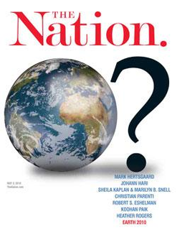
Population
Territory
Sovereignty

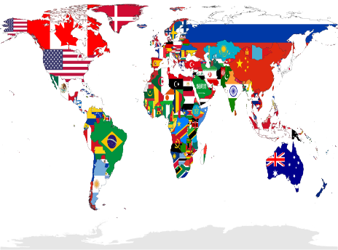

Government
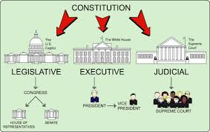
4 Theories for the Origins of the State
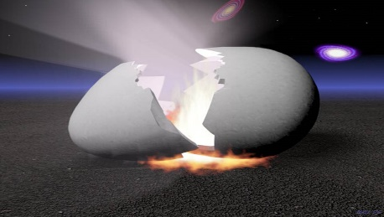
The Force Theory
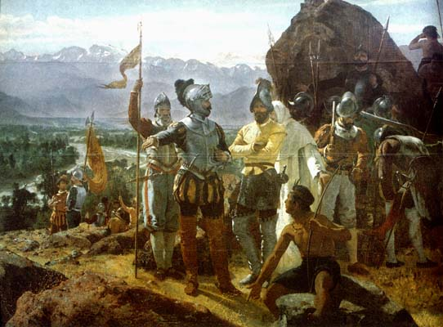
Evolutionary Theory
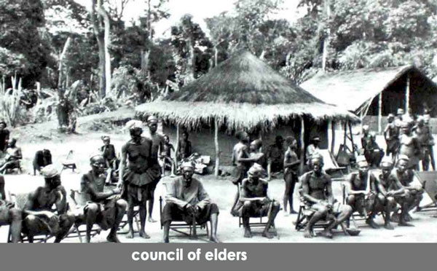
Divine Right Theory
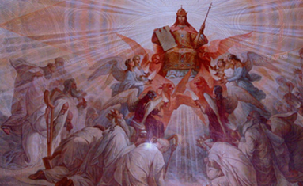
Social Contract Theory
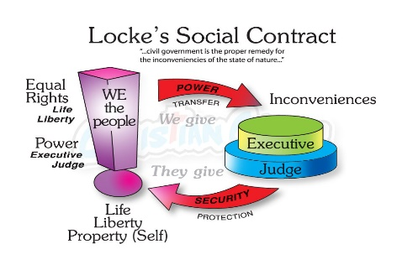
The Purpose of Government  CHECKPOINTS! | 1). What is the purpose of government? Explain in your own words.  2). Is government necessary? Why or why not?  3). Provide an historical example for each of the 4 Theories of the Origin of the State that best illustrates each theory.  EVOLUTIONARY THEORY  FORCE THEORY  DIVINE RIGHT THEORY  SOCIAL CONTRACT THEORY

