Class Notes / PowerPoint Presentation / Textbook Notes
American Government

Name:
Class:
Date:

Chapter 3: The Constitution / Section 2:
ESSENTIAL  QUESTION | How has the Constitution lasted through changing times?
FOCUS QUESTION | What are the purposes of the amendment process & its effect on the Constitution & our Federal Republic?
Objectives | - Identify the four different ways by which the Constitution may be formally changed.  - Explain how the formal amendment process illustrates the principles of federalism and popular sovereignty.  - Understand that several amendments have been proposed, but not ratified.  - Outline the 27 amendments that have been added to the Constitution.
Key Terms
amendment | a change to the written words of the Constitution
ratification | the act of approving a proposed amendment
formal amendment | one of four ways to change or add to the written language of the Constitution
Bill of Rights | the name given to the first ten amendments to the Constitution, which guarantee many basic freedoms; all ten amendments were ratified in 1791
Introduction | - How has the Constitution been amended through the formal amendment process?
Changing with
the Times

The Amendment Process

Federalism

CHECKPOINT! | How does the federal amendment process reflect the concept of federalism?
Popular Sovereignty

Proposed Amendments

The 27 Amendments

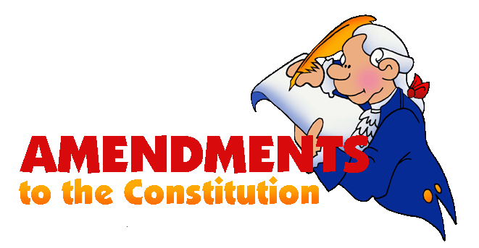
The 27 Amendments, (Cont’d)

CHECKPOINT!

ESSENTIAL QUESTION  REVIEW | What effects have the 27 amendments had on the Constitution for it to have lasted through changing times?

