Class Notes / PowerPoint Presentation / Textbook Notes
American Government

Name:
Class:
Date:

Political Behavior: Chapter 5 Section 2: Two-Party System
Government By the People in American History
in American History
Questions/Main Ideas:
Objectives | I will be able to…  - Understand the origins of political parties in the USA  - Identify & describe the 3 major periods of single-party domination & describe the current era of divided government  - Analyze & explain how the two-party system affected the history the U.S. as well as its effects on the function of government today.
Key Terms | Definitions
incumbent

faction

spoils system

electorate

sectionalism

FOCUS QUESTION | How has the two-party system affected the history of American government?
The Nation’s First Parties

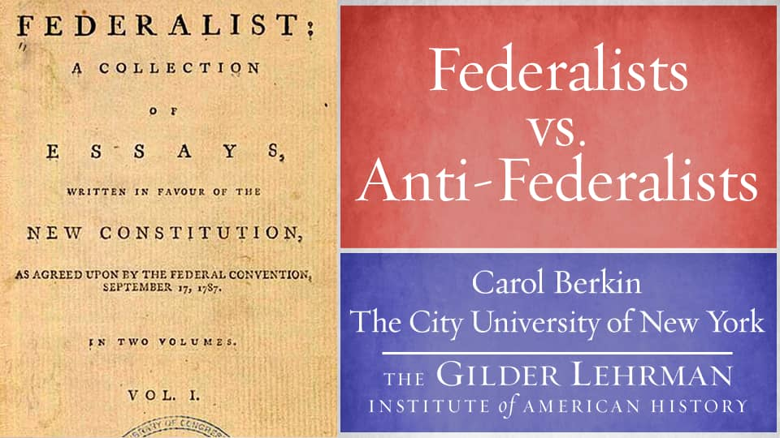
4 Major Eras of the American Two-Party Political System  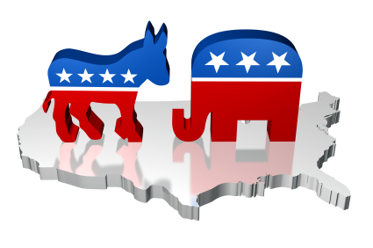  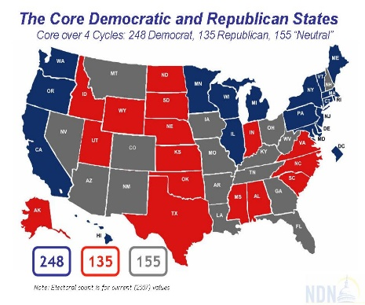  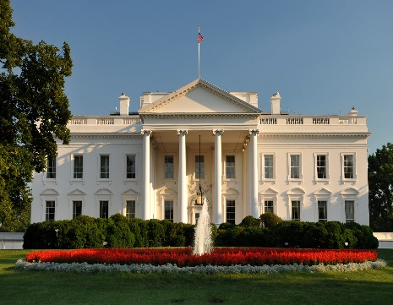  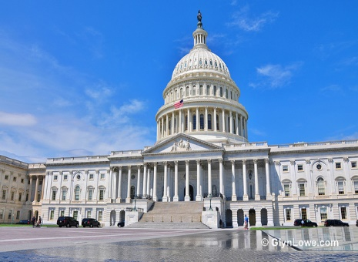 | Directions: Use p.131 of your textbook to identify & describe the 4 Major Eras of America’s Two-Party Political System. For each era, indicate the following:  - Time period, e.g. 1800 - 1860  - Which political party had dominant control of the Presidency and/or Congress?  - Cite statistics to support the electoral victories demonstrating the dominance of either party  ERA 1  ERA 2  ERA 3  ERA 4
Democratic-Republican Party

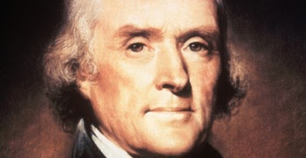
The Democratic Party

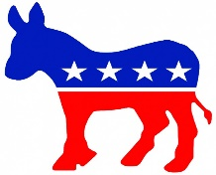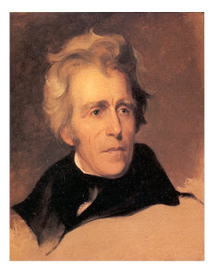
The Era of the Democrats
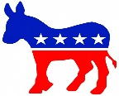
Democrats v. Whigs
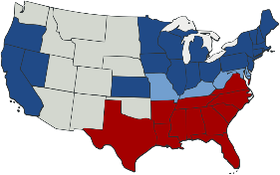
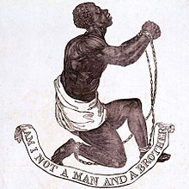
CHECKPOINT! | How are the politics of today different from past eras?
Era of the Republicans

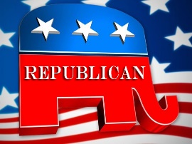
CHECKPOINT! | What 3rd Party candidate had an influence on the election of 1912? Explain in his influence on the outcome of the election.
Economic Turmoil
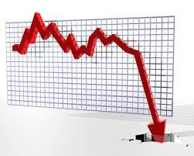
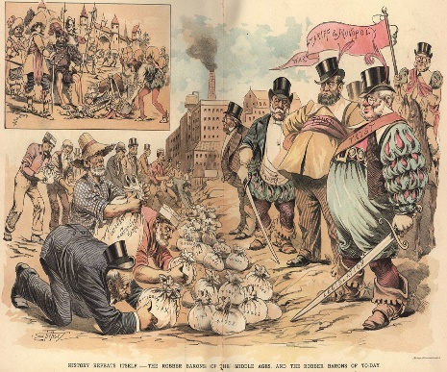
End of Republican Era

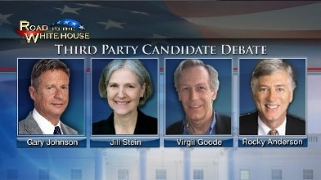
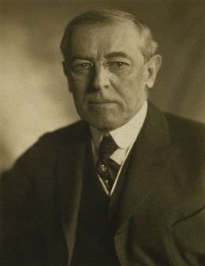
Party Identity: Past and Present
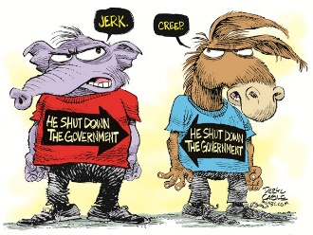
Return of the Democrats

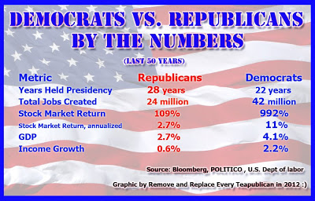
Era of Divided Government
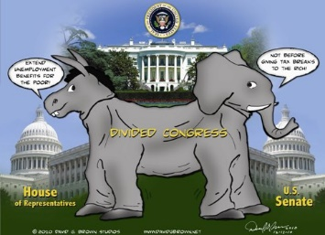
Republicans in the 1980s

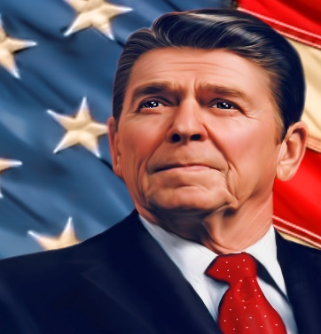
Political Parties Today
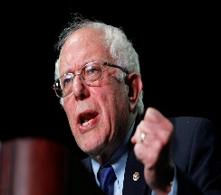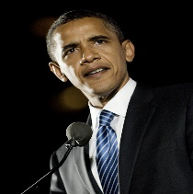
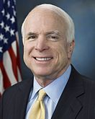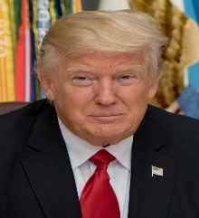
CHECKPOINT! | What does “divided government” mean?
Critical Thinking Questions | Do you think one-party rule or divided government comes closer to the ideal the Framers had when they envisioned a government without political parties? Explain.  How do political or economic crises hurt or help candidates get elected?

