Class Notes / PowerPoint Presentation / Textbook Notes
American Government

Name:
Class:
Period:
Date:

Political Behavior: Government By the People / Chapter 5 Section 1: Political Parties
Objectives | - Define a political party.  - Describe the major functions of political parties.  - Identify the reasons why the United States has a two-party system.  - Understand multiparty and one-party systems and how they affect the functioning of a political system.
Key Terms

political party | - a group of persons who seek to control government by winning elections and holding public office
political spectrum | - the range of political views, from the so-called left to the right
partisanship | - strong support for a specific political party and its policies
single-member districts | - a voting district in which only one candidate is elected to each office on the ballot
plurality | - the largest number of votes cast for an elected office; this number does not have to be a majority of all votes cast
bipartisan | - an approach to policy making in which the two major parties find common ground on an issue
consensus | - general agreement among different groups on an issue
coalition | - a temporary alliance of several groups who join to form a working majority in a multiparty system
Focus Question | What are political parties, and how do they function in our two-party system?
What is a Political Party?

CHECKPOINT! | What are the three elements that make up a political party?  1).  2).  3).
What Do Political Parties Do?
Roles of Parties

Roles of Parties (CONT’D)

Parties as “Watchdogs”
CHECKPOINT! | How do parties perform the watchdog function?
The Two-Party System

Tradition
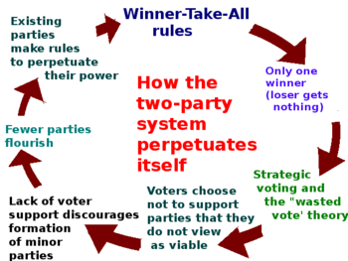

Building Consensus

Political Spectrum  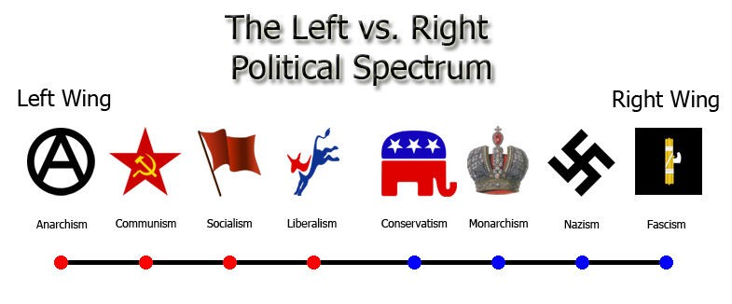  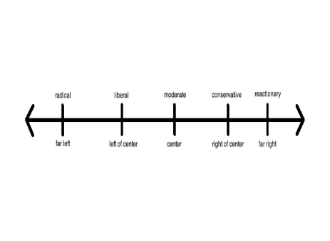 | Radical  Liberal  Moderate  Conservative .  Reactionary
CHECKPOINT! | Where do your political beliefs fall on the political spectrum? Provide 3 reasons to justify your answer.

Multiparty Systems

CHECKPOINT! | Does the two-party system help or harm democracy? Explain by providing 3 supporting details to your position?

