Class Notes
American Government

Name:
Period:
Date:

The U.S. Constitution: The Bill of Rights
Objectives | I will be able to…  - Identify & explain in my own words the purpose, meaning & significance of the first 10 Amendments of the Constitution.  - Illustrate & provide real-world/historical examples for each of the first 10 Amendments  - Analyze, evaluate & apply my understandings of each Amendment to current events in our nation
Key Terms
assembly
petition

press
due process

quarter
indicted
double jeopardy
self-incrimination
criminal trial
civil trial

jury
1st AMENDMENT

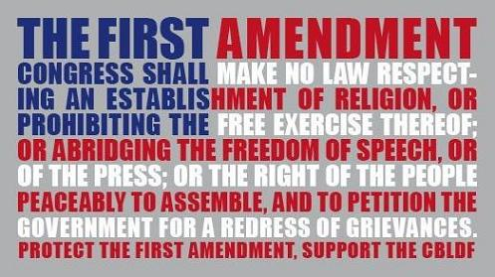
2ND AMENDMENT

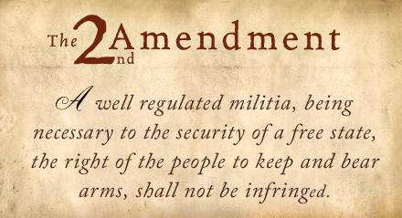

3RD AMENDMENT

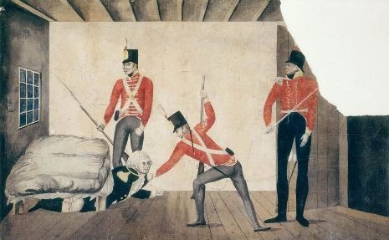
CHECKPOINT! | What are the historical origins (THINK: Colonial America/Revolutionary War) of Amendments 1 – 3?  - 1st Amendment  - 2nd Amendment  - 3rd Amendment
4TH AMENDMENT

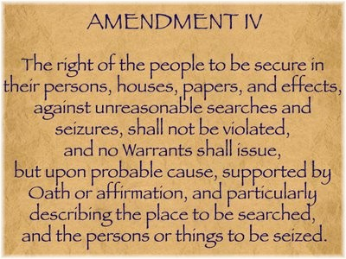
5TH AMENDMENT

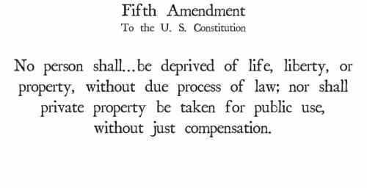

6TH AMENDMENT

CHECKPOINT! | How do the 4th, 5th & 6th Amendment guarantee the rights of the accused & due process of law?
7TH AMENDMENT

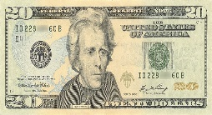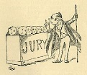

8TH AMENDMENT

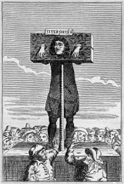

CHECKPOINT! | Some people have argued that the death penalty is a violation of the 8th Amendment? Do you agree or disagree? Why or why not?
9TH AMENDMENT

10TH AMENDMENT

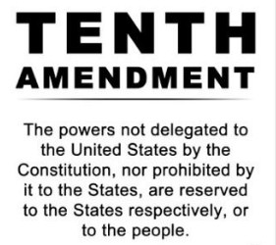

CHECKPOINT! | What is the purpose of the 9th & 10th Amendments? How are these amendments examples of the Constitutional principle of limited government?

