11TH AMENDMENT  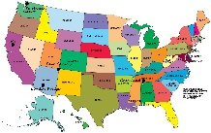 | Lawsuits Against States
12TH AMENDMENT  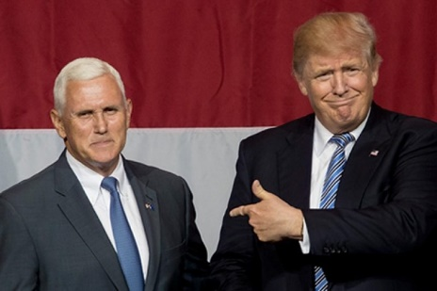 | Election of President & Vice President
13TH AMENDMENT  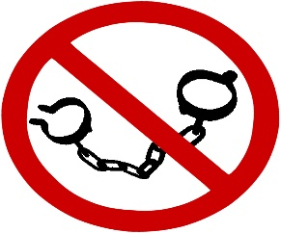 | Slavery & Involuntary Servitude
14TH AMENDMENT  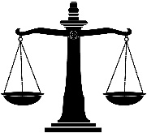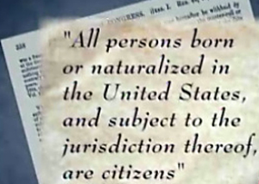  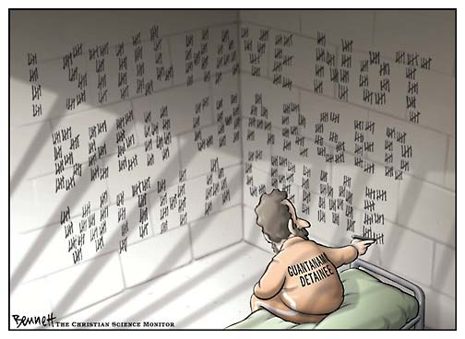 | Rights of U.S. Citizens
15TH AMENDMENT  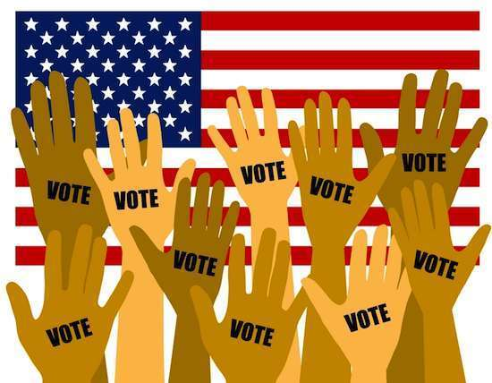 | Right to Vote – Race, Color, Servitude
CHECKPOINT | How are the 13th, 14th & 15th Amendments, known as the “Reconstruction Amendments,” a response by the United States to the Civil War?
16TH AMENDMENT  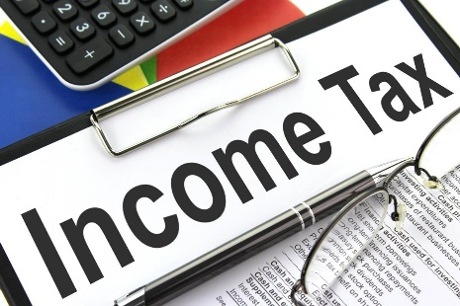 | Income Tax
CHECKPOINT | RESEARCH – Why was the income tax added to the Constitution in 1913?  Identify a PRO & CON to having an income tax?  PRO –  CON –
17TH AMENDMENT  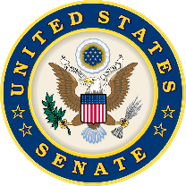 | Popular Election of Senators
18TH AMENDMENT  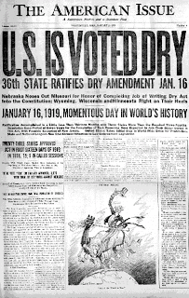 | Prohibition of Intoxicating Liquors
19TH AMENDMENT  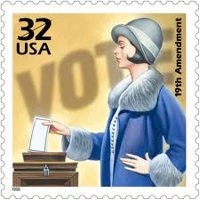 | Equal Suffrage – Sex
CHECKPOINT | HISTORICAL REFLECTION – In what ways were American women largely responsible for the ratification of the 18th & 19th Amendments?
20TH AMENDMENT  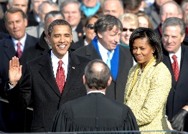 | “Lame Duck Amendment”
21ST AMENDMENT  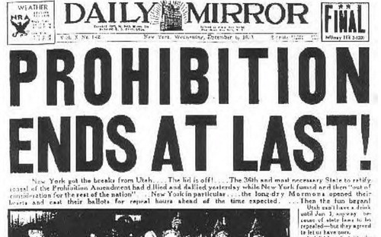 | Repeal of 18th Amendment
22ND AMENDMENT  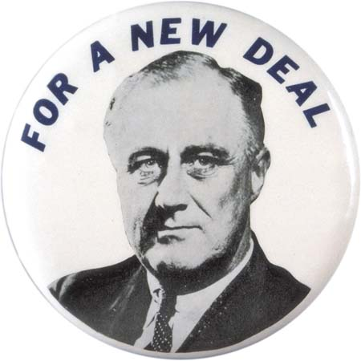 | Presidential Tenure (Terms Limits)
23RD AMENDMENT  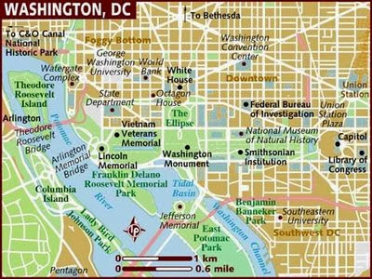 | Presidential Electors for Washington D.C.
24TH AMENDMENT  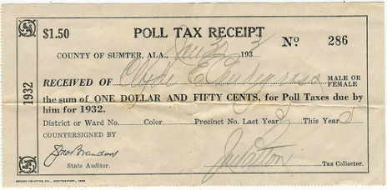 | Right to Vote in Federal Elections – No Tax Payment
CHECKPOINT | HISTORICAL REFLECTION – What was the 24th Amendment a response to? (HINT: African-American voting rights in South)
25TH AMENDMENT  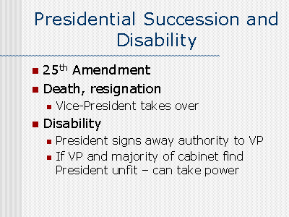 | Presidential Succession, Vice Presidential Vacancy, Presidential Inability
26TH AMENDMENT | Right to Vote – Age
27TH AMENDMENT  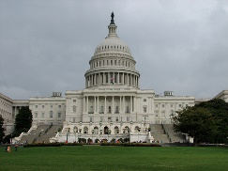 | Congressional Pay
CHECKPOINT | A 28th Amendment? If you could fight for a 28th Amendment, what would it be & why?

